**EQUIPMENTS REQUIRED**

* Chasis
* 4 wheels
* 4 DC Motors
* 12 V battery
* IR sensors
* Bread board
* Jumper wire
* Arduino UNO
* Motor Driver

**IMPORTANT COMPONENTS OF THE BOT**

To build an efficient **Line Follower Bot**, we need the following key components: **IR Sensors**, a **Motor Driver**, and an **Arduino** microcontroller. Each component plays a crucial role in ensuring that the bot can detect lines, make decisions, and move accordingly. Here's a detailed explanation of how each component is used in our bot:

#### ir 2.PNG1. ****IR Sensors (Infrared Sensors)****

**Function**:

* The bot uses **three IR sensors**: **Left**, **Middle**, and **Right**.
* These sensors are responsible for detecting the black line on a white surface.

**Working Principle**:

* Each IR sensor emits infrared light and detects the reflection from the surface.
  + **White Surface**: Reflects most of the infrared light (sensor output = **0**).
  + **Black Line**: Absorbs infrared light (sensor output = **1**).
* **Decision Making**:
  + The sensors provide real-time feedback to the Arduino, which then decides whether to move forward, turn left, or turn right based on a pre-defined algorithm (left or right prioritized).

**Sensor Placement**:

* The sensors are mounted at the front of the bot with slight spacing to cover the width of the line and detect junctions efficiently.

#### 2. ****Motor Driver (L298N Motor Driver Module)****

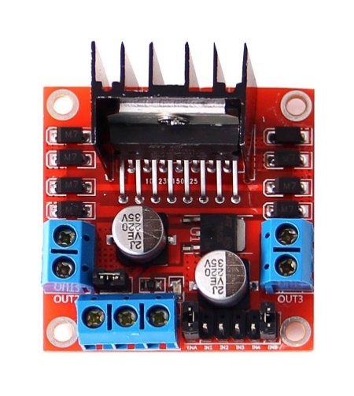**Function**:

* The motor driver controls the speed and direction of the **DC motors** attached to the wheels of the bot.
* It acts as an interface between the low-power Arduino and the high-power motors.

**Working Principle**:

* The **L298N Motor Driver** has two channels (Channel A and Channel B) to control the motors independently.
* It receives control signals from the Arduino:
  + **IN1, IN2**: Control the left motor (connected to one wheel).
  + **IN3, IN4**: Control the right motor (connected to the other wheel).
* By setting these pins to HIGH or LOW, the bot movement can be controlled.

**Power Supply**:

* The motor driver can handle a higher voltage (typically 7V-12V) from an external battery, which is necessary to drive the motors effectively.

#### 3. ****Arduino (Arduino UNO)****

**Function**:

* The **Arduino UNO** acts as the brain of the line follower bot.
* It processes input from the IR sensors and sends control signals to the motor driver.

**Working Principle**:

* The Arduino reads the digital signals from the IR sensors (connected to its digital input pins).
* It uses a **predefined algorithm** (left-prioritized or right-prioritized) to make decisions based on the sensor inputs.
* Based on the algorithm, the Arduino sends output signals to the motor driver to control the bot’s movement.

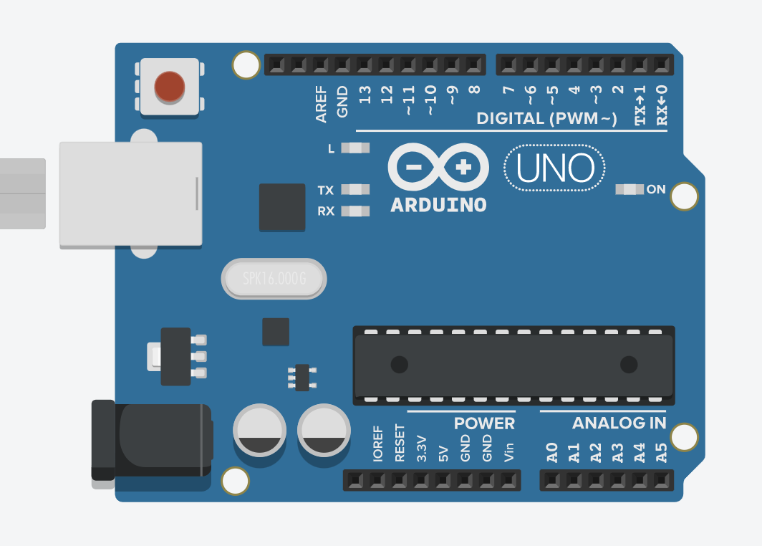

**CIRCUIT DIAGRAM**

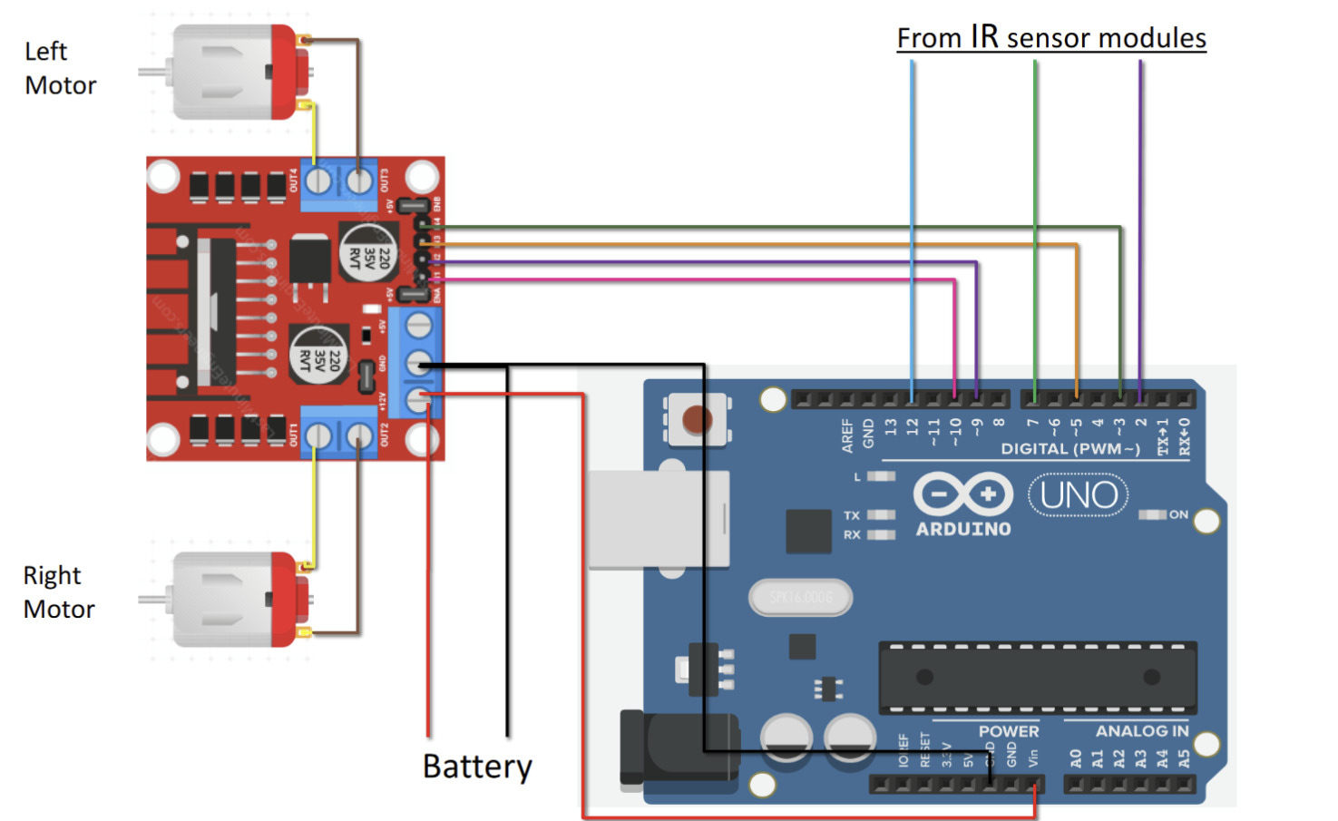

Basically there are in total 4 motors ,the other two will also connect in the same manner as shown in the circuit diagram, from the same output terminals of motor driver.

The battery used provide 12 V supply.